Job Search Target Area

What is your job search target area?

1.
2.
3.

Have you considered relocating?

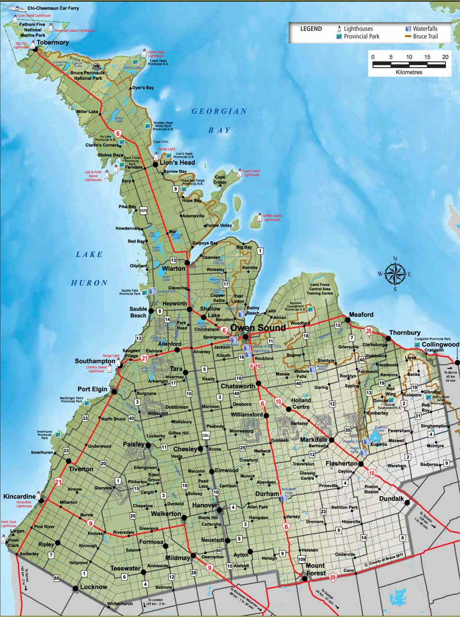

Note: These materials have been developed and adapted from a range of sources for the purpose of the Bruce County Job Search Club.

